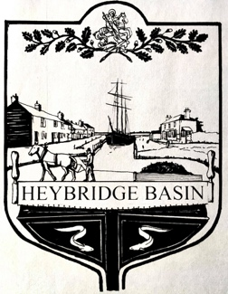
HEYBRIDGE BASIN PARISH COUNCIL

INTERIM OCTOBER NEWSLETTER

Welcome to this interim edition of the Heybridge Basin Parish Council newsletter.

The Current Situation
In our last newsletter we advised you of the resignation of the Chair of Heybridge Basin Parish Council, Bryan Harker.

We are pleased to tell you that Bryan’s replacements have been appointed by Maldon District Council at their meeting on 1st October 2020. Your new Parish Councillors are District Councillor Anne Beale and Heybridge Basin resident Keith Lawson.
Anne Beale
Anne is well known in the area having been both a Heybridge Parish Councillor and a Maldon Town Councillor. She served a term as chair of Heybridge Parish Council. She was elected as a District Councillor in 2007 following which she resigned her positions with Heybridge and Maldon so that she could devote more time to District matters.

Anne has lived in Heybridge since about 1977 and is very much aware of the history of the area and the issues of importance not only to residents in the wider area but also to residents of Heybridge Basin.

In her own words she became a Councillor at Parish, Town and District level as she “wanted to be involved in hopefully making the area a better place to live for all our constituents, families and visitors and having a chance to improve the flood risk and our environmental impact on our area”.
Keith Lawson
Keith worked in Local Government for 40 years, the last twenty in a senior position as a Head of Service. He has experience in Highways, Planning, Lead Flood Authority and European Projects. He is a Fellow of the Institute of Highway Engineers.

On retirement Keith joined Heybridge Parish Council as he felt his experience in Local Government would be useful to the community. He was Chair of the Planning Committee for a time and, with the Ward Member, attended and contributed to the Maldon Local Plan Inquiry

He has lived in the Basin for 40 years and is now in his third house! He is a keen sailor and has been Chairman of the Regatta Committee for sixteen years.

He was part of the secretariat of the Referendum Team that steered the process of creating Heybridge Basin Parish Council.

Going forward
Following the appointment of our new Councillors we will be holding our next Council meeting at 3.00pm on Friday 9th October 2020. This will be a virtual meeting and is open to the press and members of the public. Details as to how to join the meeting can be obtained by e-mailing the Clerk on the morning of 9th October 2020.

2nd October 2020

